Talking Saves Lives digital toolkit



Sheffield City Council has worked with mental health charity Sheffield Flourish to create a suicide prevention campaign – Talking Saves Lives.
The campaign aims to:
- encourage people to reach out, talk, and seek help if they are struggling with their mental health and/or considering suicide
- inform those struggling with their mental health and/or at risk of suicide that help is available and signpost people to relevant resources
- help people understand and recognise the signs of symptoms of depression/stress before it gets to suicidal thoughts
- educate friends, family, and co-workers on the signs that someone is struggling with their mental health and/or feeling suicidal and empower them to help
- reduce the stigma attached to mental health struggles and suicide by using clear language
You can find more information at www.sheffieldsuicidesupport.co.uk

What we’d like from you
We’d like your help to raise awareness of the campaign, so it reaches as many Sheffield people as possible.
We have created a digital toolkit for you, which includes:
- A4 posters
- A3 posters
- Branded images for use online, on social media, and in print
- Suggested social media posts

Printed materials
If you would like printed versions of the posters, we are happy to provide them.
We can also provide these info cards (credit card sized):

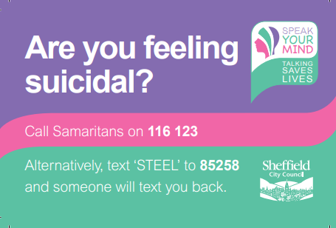
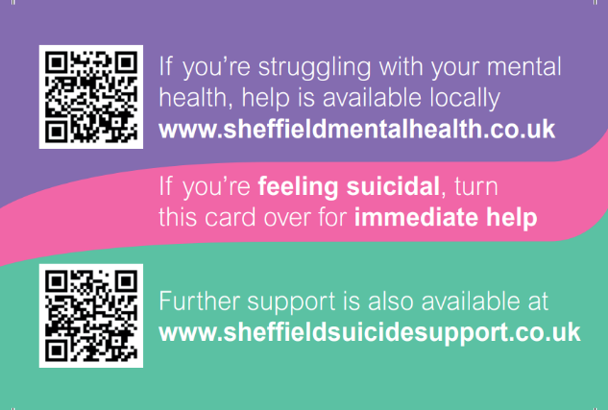

Related resources
www.sheffieldsuicidesupport.co.uk
www.sheffieldmentalhealth.co.uk
www.samaritans.org
https://giveusashout.org/
South Yorkshire - Amparo

Thank you for your support
If you have any questions, or would like to order some printed materials, please contact Stephanie Swales on stephanie.swales@sheffield.gov.uk or 0114 205 6941.

