Social media plan | Suicide Prevention – Talking Saves Lives

Image/video | Text | Alt text for image
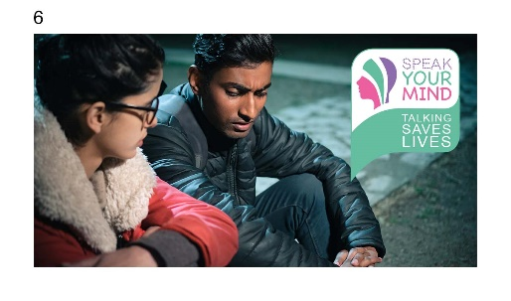 | If you are feeling suicidal, or know someone who is, local support is available at www.sheffieldsuicidesupport.co.uk.  The Sheffield Mental Health Guide has information and contact details for over 300 mental health friendly services across the city. Find it here www.sheffieldmentalhealth.co.uk  If you need immediate help, please call 999.  #Sheffield #TalkingSavesLives #SuicidePrevention #MentalHealth | A young man and woman sit together talking outside at night. The man looks unhappy, the woman listens.
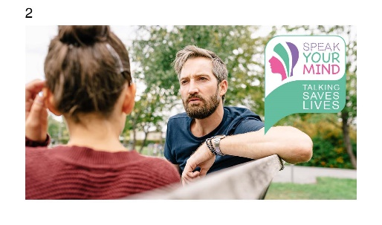 | ‘Are you OK? Are you really OK’?  Asking twice lets someone know you are not just asking out of habit.  If you think someone could be feeling suicidal, please let them know that local support is available at www.sheffieldsuicidesupport.co.uk  The Sheffield Mental Health Guide also has information and contact details for over 300 mental health friendly services across the city. Find it here www.sheffieldmentalhealth.co.uk  #Sheffield #TalkingSavesLives #SuicidePrevention #MentalHealth | A man and younger woman sit on a park bench. The man looks concerned. The woman is tucking hair behind her ear.
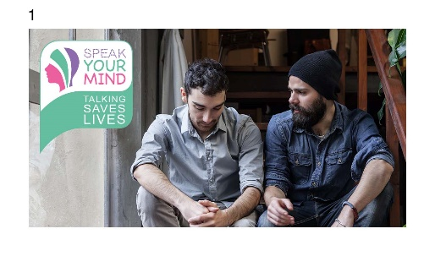 | If you thought a family member, friend, or colleague was feeling suicidal, would you know what to do?  Take the free training and, like 2 million others, in just 20 minutes you’ll learn how to help.  Find out more at www.zerosuicidealliance.com/suicide-awareness-training  #Sheffield #TalkingSavesLives #SuicidePrevention #MentalHealth | Two young men sit on a staircase side by side. One talks while the other bows his head
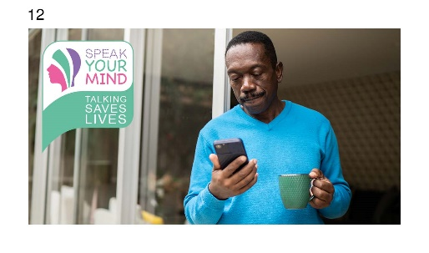 | If you are feeling suicidal, please reach out for support. No judgement, no pressure.  It’s OK not to be OK.  Find out how to get help at www.sheffieldsuicidesupport.co.uk  If you need immediate help, please call 999.  Information on over 300 mental health services around the city are listed in the Sheffield Mental Health Guide. Find it at www.sheffieldmentalhealth.co.uk  #Sheffield #TalkingSavesLives #SuicidePrevention #MentalHealth | A man stands by on open door holding a cup while looking at his phone
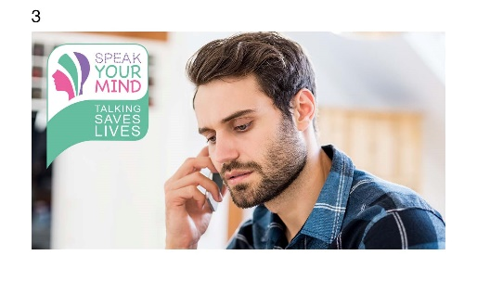 | Suicide is a tragedy, and it is preventable. If you’re having suicidal thoughts, please get help and talk to someone.  Find help at www.sheffieldsuicidesupport.co.uk  If you need immediate help, please call 999.  The Sheffield Mental Health Guide also has information and contact details for over 300 mental health friendly services across the city. Find it here www.sheffieldmentalhealth.co.uk  #Sheffield #TalkingSavesLives #SuicidePrevention #MentalHealth | A young man with a serious expression holds a phone to his ear
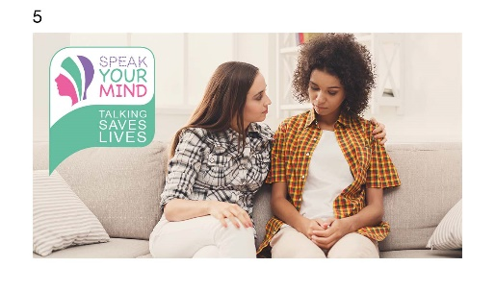 | More than 2 million people worldwide have done the free, 20-minute training by Zero Suicide Alliance. It teaches you how to recognise when someone is feeling suicidal, and how to help them.  Find out more at www.zerosuicidealliance.com/suicide-awareness-training  #Sheffield #TalkingSavesLives #SuicidePrevention #MentalHealth | Two young women sit together on a sofa talking. One has her arm around the other.
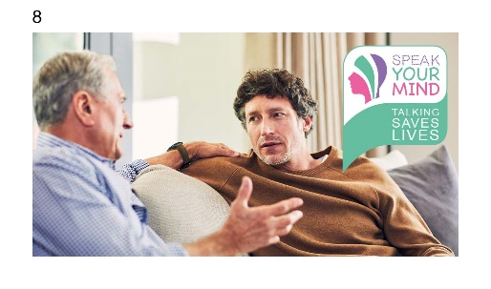 | Every week, one person dies by Suicide in Sheffield. If you’re having suicidal thoughts, please get help and talk to someone.  Find help and support at www.sheffieldsuicidesupport.co.uk  If you need immediate help, please call 999.  Information on over 300 mental health services around the city are listed in the Sheffield Mental Health Guide. Find it at www.sheffieldmentalhealth.co.uk  #Sheffield #TalkingSavesLives #SuicidePrevention #MentalHealth | Two men, one older, sit together on a sofa talking

